

**UTC2720**

**Income Inequality: A Teleological Perspective**

**Professor Venkat Venkatsubramanian**

**Laya Das**

**Abhishek Sivaram**

**Members:**

|  |  |
| --- | --- |
| **Emma Tan Xin Rong** | **E0319013** |
| **Tan Kai Qun, Jeremy** | **E0272509** |

**Date of submission: 29 July 2019**

Part 1

**Analysis of income distribution in different countries.**

The maximum, minimum, average wage for each country is obtained from the table below (figure 1) with the inclusion of 3% inflation for each year for consistency. Thus, the maximum salary can then be calculated. However, data for Singapore and Malaysia are not included in the table thus the maximum wage for each country has to be determined through online research made with reasonable assumptions. In this paper, we are going to examine the income distribution for each country in the past 40 years.

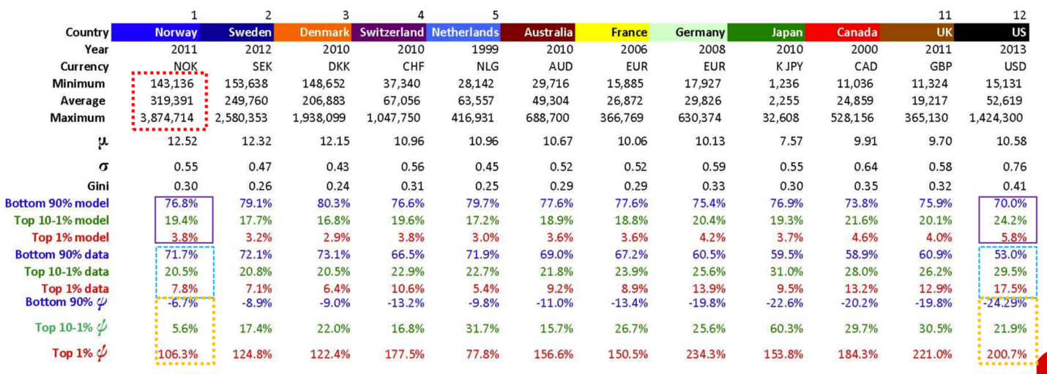

Figure 1: Income statistics table

The following equations listed below will be used to calculate sigma and miu, and determine the lognormal distribution for a given country. An ideal society has a Ψ value of 0.

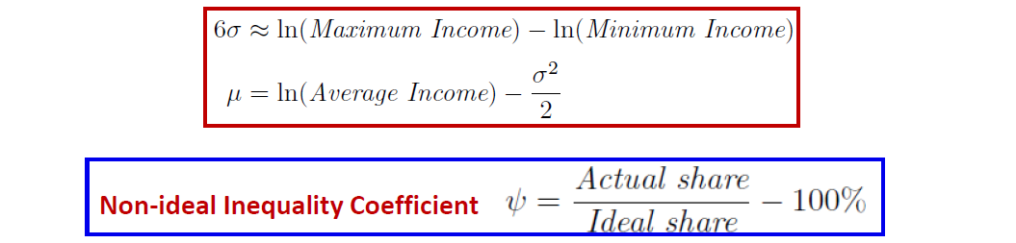

In order to calculate the alpha, beta, gamma, the following steps are used: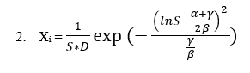

Comparing 1 and 2, the following relation is obtained

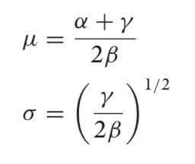

The alpha, beta and gamma can then be determined.

Note: The income statistics taken is in each country’s currency.

1.1 Singapore

**Singapore (Table Form):**

Singapore has no concrete minimum wage policy in the fear that by implementing the policy, companies go bust and the unemployment rate will increase (<https://www.theedgesingapore.com/minimum-wage-singapore>).

However, there are certain guidelines to follow. For example, cleaners are to be paid at least SGD1000/month but the minimum wage is specific to occupation and not nationwide.

The maximum wage in Singapore for this project is taken to be the salary of the Prime Minister. The prime minister salary is found to be pegged within the top 0.1% of Singaporeans after taking a pay cut.

<https://blog.seedly.sg/salary-guide-singapore/>

|  |  |
| --- | --- |
| **DATA GROUP** | **Income (2018)** |
| **Minimum Wage**  **Average Wage**  **Maximum Wage** | ~SGD12000/year  SGD67,152/year  SGD2.2 million/year |

1.1.1 Income distribution over the years

Pre-Tax

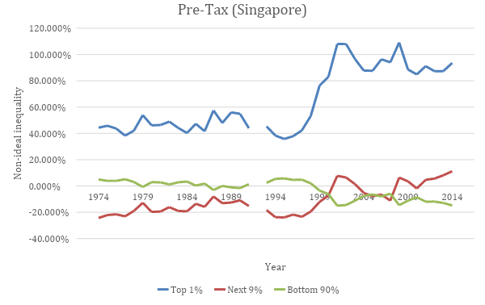

There is a lack of data found in 1992 as well as the lack of post-tax data.

**ANALYSIS**

As observed over the years, the non-ideal inequality for the top 1% from the year 1974 to 1991 is fairly consistent, hovering around an average of 51% more than the ideal inequality line of 0%. However, from the year 1998, its Ψ value spiked and reached a peak high in 2001 with a value of 107.971%. This value indicates that the top 1% in that year has an income share of 107.971% more than the ideal share.

For the next 9%, initially from the year 1974 to 2000, its Ψ value is lower than 0% and has reached the negative value range. This indicates that the income share owned by the top 1-10% is lower than the ideal share which means that they are receiving less than the amount they should receive. From the year 2000 to 2014, its Ψ value fluctuates around the ideal inequality line but there is a general trend of a gradual positive increase in Ψ value from 2010 which means that that the income share owned by the top 1-10% is slowly growing. This behaviour is further accentuated when we examine the change in Ψ value for the bottom 90%.

For the bottom 90%, initially from the year 1974 to 2000, its Ψ value is higher than the ideal inequality line of 0%. This means that the bottom 90% was receiving more than the ideal amount of share. It is interesting to note that around the late 1980s, the share of the bottom 90% is actually extremely close to ideal. However, from the year 2000 to 2014, the income share owned by the bottom 90% started to decline and this causes its Ψ value to also decrease, and subsequently enter the negative value range, indicating that they are owning less than the ideal share. This supports the behaviour we observed for the Ψ value of the top 1-10% in recent years. Since the share of the top 1%, next 9% and the bottom 90% must add up to 100%, a decrease in the share of the bottom 90% will correspond to an increase in either or both the share of the top 1% and the next 9%. In other words, if the bottom 90% is beginning to own less than the ideal share, we can observe that the top 1% or the top 1-10% is beginning to own more than the ideal share. In our case, we can observe that the Ψ value of the top 1-10% is gradually increasing while the Ψ value of the bottom 90% declines in recent years.

Comparing all 3 income groups, it can be observed visually that the corresponding Ψ values of the 3 groups are relatively stable and even improving from 1974 to 1992. However, from the year 1993 onwards, there seems to be a drastic change in their Ψ values and an overall increase in inequality in the income distribution ever since then. It was also in this same period that Singapore experienced a rapid economic growth and was emerging as a 1st world country. This is a rather puzzling result since rapid economic growth is a good thing but statistics have shown that the inequality is actually widening. This leads our group to believe that perhaps there is a positive correlation between the rate of economic growth and widening income inequality. It is important to note that a high rate of economic growth does not mean that the rate will be sustainable. What we meant over here is that when a country experiences a rapid boost in economy in an extremely short period of time, there is a high probability that it is the top 1% or the next 9% who will benefit the most from this. This is because this group of people are the executives and they are the ones who control the income distribution of the corporations. Therefore, empirically, they would benefit more from economic growth and earn more as a result, hence a widening income inequality.

2.1 Malaysia

**Malaysia (Table Form):**

<https://www.imoney.my/articles/malaysia-highest-paying-jobs-2017>

|  |  |
| --- | --- |
| **DATA GROUP** | **Income** |
| **Minimum Wage (2018)**  **Average Wage (2017)**  **Maximum Wage (2017)** | MYR12,600/year (~SGD4,174.55)  MYR60,000/year (~SGD19,877.5)  MYR999,996/year(~SGD331,290.4) |

2.1.1 Income distribution over the years

Unlike many other countries, Malaysia has many gaps in its data with missing values and income share for quite a number of years. Therefore, the analysis can only be done with limited data.

Pre-Tax

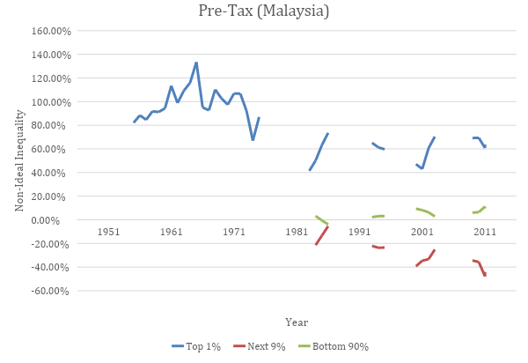

**ANALYSIS**

In terms of the data obtained for Malaysia, a whole set of post-tax data appeared to be missing thus only the pre-tax information can be analysed. As previously mentioned, the data set for the pre-tax data has large chunks of missing information over the years, thus the analysis of it is limited to only the data available.

Surprisingly, with the talks of corruption in Malaysia, coupled with Malaysia having a corruption perception index of 47 which is perceived as more corrupt, the income share owned by the top 1% is actually closer to the ideal condition of 0% in the later years as compared to in the mid-20th century. From 1983 to 2011, with the discontinuous data, it is still observable that the top 1% owned about ~60% more than their fair share, with it reaching a low of 40% to a high of only ~78%. This comes as a surprise as the top 1% in Malaysia is widely regarded as being highly corrupted and yet they owned ~60% more than their fair share which is considered relatively fairer than the top 1% in the other countries discussed in this report.

On the other hand, the top 1-10%’s income share is slowly declining from 1984 to 2011. In 2011, the share owned by them has reached a new low of 47.8% less than their fair share. It is interesting to note that the Ψ value of the bottom 90% seems to be consistently above the ideal inequality line. This is a rather unusual trend as, more often than not, the bottom 90% is always receiving less than their ideal share especially in recent years. However, for the case of Malaysia, its bottom 90% is in fact owning more than their fair share.

3.1 Norway

**Norway (Table Form):**

For the case of Norway, when minimum wage is mentioned, it varies from economic sector to sector, by taking into consideration all the minimum wages for each sector, the lowest minimum wage is then taken. Only the wage of skilled workers is considered. It is discovered that the sector of agriculture and horticulture has the lowest minimum wage of ~NOK154.80/hour. Assuming a 38 hour work week according to Eurofound and taking into consideration the 3% inflation each year from 2011 to 2016. (Note: 3% inflation rate is added to the maximum wage from the year before)

|  |  |
| --- | --- |
| **DATA GROUP** | **Income** |
| **Minimum Wage**  **Average Wage**  **Maximum Wage** | ~NOK165,933.85/year (~SGD26,333.28)  ~NOK709,439/year (~SGD111,577.02)  ~NOK4,491,855.485/year (~SGD712,845.99) |

The average income obtained from the WID for Norway with regards to pre-tax and post-tax are similar. As such, it is assumed that the income taxation does not affect the average income.

3.1.1 Income distribution over the years

Pre-Tax

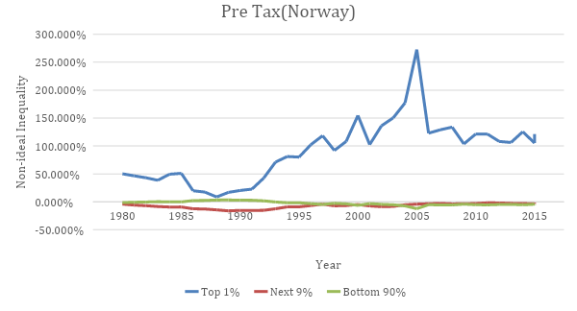

**ANALYSIS**

At first glance of the income distribution in Norway with regards to the pre-tax data, it is observed that Norway is the closest to reaching a utopian state as majority of its population (99%) is extremely close to the ideal inequality line of 0%. Despite a couple of wavering years while the income share fell below the ideal line, in general, the bottom 90% and the top 1-10% hovers around the ideal line. From 2007 onwards, the bottom 90% and the top 1-10% are more or less on the ideal line with only a small difference between their actual income share and the ideal income share of ~+-4%.

The top 1% however are still receiving a whole lot more than their fair share. In the year 2005, the top 1% reached a new high of 272.591% more than the ideal share. This is an unusual spike in income share compared to the rather consistent values. On further research of events that occurred in 2005, it is noted that the Parliamentary election occurred in 2005 which could have led to conditions that improved the economy for the top 1% in Norway. Another important date to note is in 1988 where, on visual observation, the entire population’s income share is the closest to the ideal inequality line. The top 1% only owned 8.683% more, the bottom 90% owned 3.235% more and the top 1-10% owned 14.47% less than the ideal share.

Post-Tax

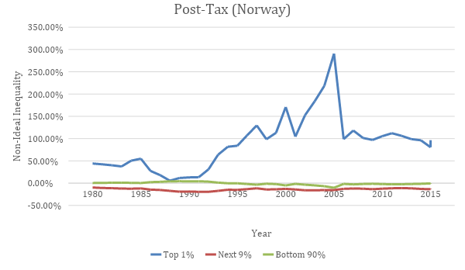

**ANALYSIS**

The overall shape of the graph for Post-Tax data in Norway is pretty much similar to the Pre-Tax data, this means that the taxation rate does not have a drastic effect on the population income distribution. Further examination on the graph reveals that the top 1-10% is receiving less than their fair share in post-tax as compared to pre-tax. The red graph representing that income group is relatively lower than the ideal inequality line of 0% in post-tax compared to pre-tax. Similarly, by comparing the data and trend of the post-tax and pre-tax income share owned, it can be observed that the bottom 99% owns a lower percentage of the income pie after taxation as compare to the top 1%. For instance, in 2003, the pre-tax data shows that the top 1% owned 150% more than the fair share. The post-tax data however suggests that the top 1% owned 183.74% more than the fair share after taxation is included. This example suggests that the amount of taxation on the top 1% may be insufficient to offset/balance out the large proportion of share owned by them. As such, the top 1% is still receiving more than their ideal fair share even after taxation.

The data however could be incomplete and inaccurate, this is because as mentioned previously, the post-tax data (Maximum, Minimum and Average Income) found on the internet and the World Inequality Database is similar to the pre-tax data. It has to be noted that the top 1-10% is actually not receiving their fair share, in fact, they are receiving less than what they are supposed to receive.

4.1 USA

**USA (Table Form):**

The minimum wage in the USA is USD7.25/hour since 2009. In the US, a full-time work week is 2,080 hours per week. Therefore, the annual earnings by an ordinary American citizen would be USD$15,080

|  |  |
| --- | --- |
| **DATA GROUP** | **Income** |
| **Minimum Wage**  **Average Wage**  **Maximum Wage** | $15,080/year (~SGD20,576.66)  $66,220/year (~SGD73,730.37)  $1,467,029/year(~SGD1,995,746.25) |

4.1.1 Income distribution over the years

Pre-Tax

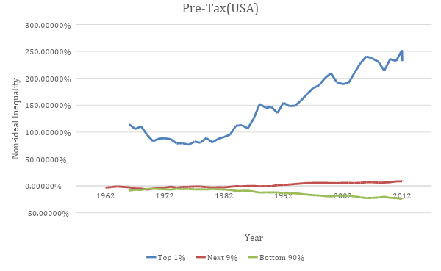

**ANALYSIS**

Based on visual observation, it is seen that in the US, the income share owned by the bottom 90% decreases over the years. On the other hand, the income share owned by the top 1-10% gradually increases over the years. The bottom 90% was initially close to the ideal inequality line but ever since the 1980s, its Ψ value has been declining which means that they are receiving lesser and lesser than their fair share. For the top 1%, its Ψ value has been steadily increasing since the same time period of around 1980s. In recent years, its Ψ value has reached as high as 252% more than the ideal amount.

Post-Tax

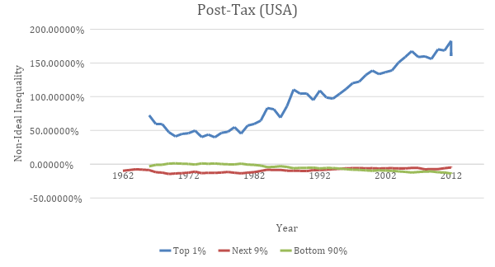

**ANALYSIS**

For the post-tax data, the bottom 99% is much closer to the ideal inequality line. This is especially so for the bottom 90% where its Ψ value is ~-10% in post-tax as compared to ~-20% in pre-tax in recent years. From 1966 to 1981, the bottom 90% achieve almost close to 0% deviation from their ideal fair share. Like the pre-tax data, over the years, the bottom 90% is receiving lesser and lesser than their fair share from the year 1982 onwards while the top 10%’s share is on an incline.

However, a difference between pre and post-tax data is that the pre-tax data shows that the top 1-10% is earning more than their ideal share while the post-tax data indicates that they are in fact earning less than ideal. This could mean that the tax policies in US may not be ideal and beneficial to the top 1-10%. In other words, more research can be done on US taxation policies and the Ψ value could be used as a reference to guide government in formulating tax policies which restore fairness to its society’s income distribution.

5.1 Japan

**Japan (Table Form):**

The average working hours for full-time work in Japan is 1,714 hours a year. Using this information, the annual salary for minimum, average and maximum can then be calculated.

|  |  |
| --- | --- |
| **DATA GROUP** | **Income** |
| **Minimum Wage**  **Average Wage**  **Maximum Wage** | 2,118,504 Yen/year  3,768,919.53 Yen/year  55,890,112 Yen/year |

5.1.1 Income distribution over the years

Pre-Tax

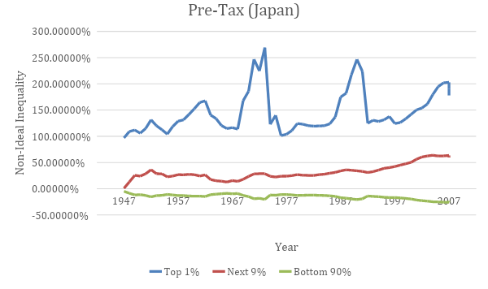

**ANALYSIS**

There is a general trend of widening inequality in Japan where the Ψ value of the bottom 90% is steadily declining while the Ψ values of the top 10% is increasing over the years.

Two unusual peaks for the top 1% can be observed. In 1973, the top 1% received 269% more share than ideal in a span of 1 year, that value decreased by more than half to only 123%. On further research, it is discovered that in October 1973, Japan faced a severe oil crisis with the price of oil rising to 400%, resulting in that observed peak.

The 2nd unusual peak occurred in 1990, with a landslide decline in the following few years. Research showed that in the 1990s, Japan was experiencing an economic turmoil, titled the Lost Decades which was a period of economic stagnation. This caused the economy to suffer and perhaps the plummet in the share of the top 1%.